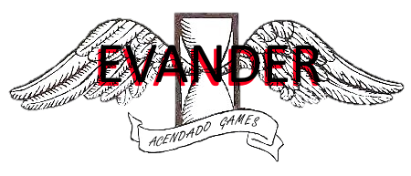

**The Game**

Evander is a rushing 2D hack and slash platformer, where the player will need to master his time and space traveling newly discovered abilities in order to advance through upcoming difficulties.

Only available for PC platform. Intended for a public between 12 and 30, ESRB: TEEN. Main Aesthetics: Fantasy through a legendary environment, narrative through its straightforward deep story and challenge.

**Backstory**

You gain control over Roman’s Golden Era gladiator Evander, in his quest to dethrone Janus, the god who locked his memories behind the Doors of Past. When the wait for revenge comes to an end you’ll fight Janus to not only lose your battle but also hope. Yet destiny finally gets on your side and allows you to manage a glimmer of his powers as he punishes you to redeem your sins from the past. What he couldn’t expect was you rising against his power in an epic journey, being the only way to get your memory back defeating him and taking his place in the Roman Pantheon.

**Core Dynamics**

Classical 2D platformer WASD controls combined with a cutting edge dashing system, which allows the player to select the nearest enemy target by pressing the space bar and dashes you towards him, to boost the experience of a game that bets on speed and skill. At the same time to make defense a dynamic element, dodge has come to be the unique defensive system in either ways: with classical WASD dodging or with the time rewinding mechanic that will also help you to advance through some levels and even refill your life bar making each gameplay unique.

The Dashing and Time Rewinding mechanics will have restrictions during the gameplay which will only allow the most skillful players to master the game.

**Gameplay**

You will rush through levels combining the gladiator’s sword ability, the dashing and the time rewinding powers to destroy the enemy forces to fulfil your destiny. Different levels intended to the multiple strengths Evander has will be implemented, most likely containing timed puzzles and easy jigsaws.

**Unique Selling Point**

The mechanics of Evander and its easy-going but deep story are what makes this game a unique piece in his genre. Feeling an unstoppable nature force, who braves fearless gods face to face together with the combination of speed, strength and skill in your way through Roman mythology makes this a sales hit.

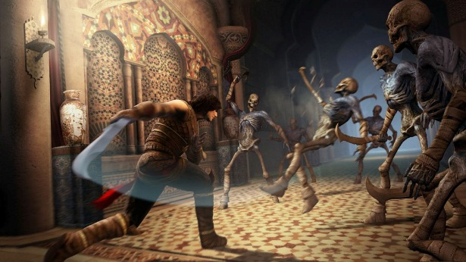**REFERENCES**

* *Prince of Persia*

Prince of Persia’s Hack and Slash gameplay and time traveling

mechanics are a fundamental part of the games core.

* 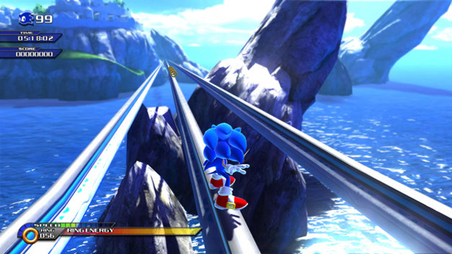*Sonic unleashed*

The rush concept and the aiming mechanics are a one of the

important references we took from the sonic franchise.

* 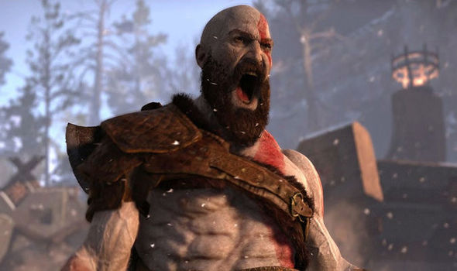*God of War*

Backed up the main ideas for the story and narrative intended, the

suggestion of someone “rebelling” against the force of the gods